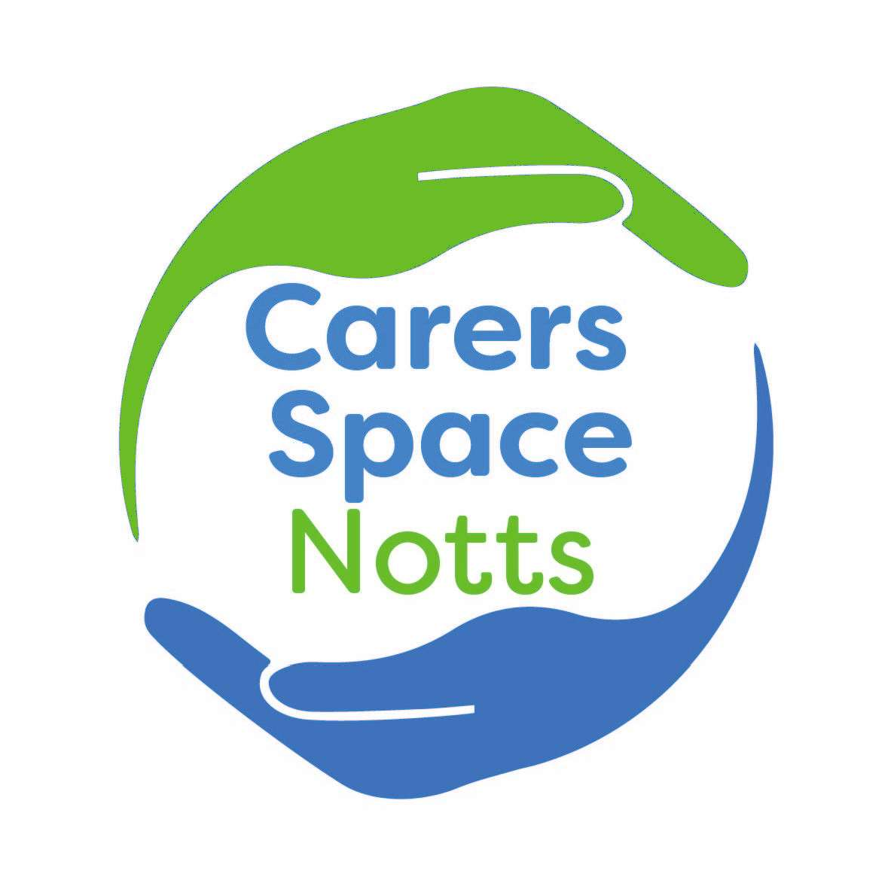

Carers Space Notts
Who are we?
- We are a group of unpaid carers and professionals who are passionate about carers having an equal voice with professionals when strategic decisions are made about services or policies impacting carers in Nottinghamshire.

How did we start?
- At a listening event with Adult Social Care in July 2021 a carer raised concerns about the opportunities for carers to get involved and influence how services develop in Nottinghamshire.

- Adult Social Care asked Nottinghamshire Carers Association to work with them and carers to design a way for more carers to get involved in strategic projects.

Our aim
To ensure services and policies are developed and improved by carers having an equal voice when developed and reviewed in Nottinghamshire.

Why?
Although carers are at the heart of social care support in the UK, many feel unsupported and under strain.
Ensuring carers are an equal partner in designing services and policies that affect them in Nottinghamshire is an important part in trying to minimise the difficulties they experience and optimise services and support that works

Connection to ‘The Carers Strategy’

The 2023-2028 Joint Carers Strategy was co-produced with Carers. A core part of the strategy is the ‘I’ and ‘We’ statements that demonstrate Carers’ wishes from services. Several of the ‘I’ statements are relevant to Carers Space Notts:

‘I want to be able to access information and support when I need it’

‘I want to feel valued and listened to’

‘I want to be able to share my experiences with other carers in ways that are accessible to me face-to-face, virtual or otherwise’

‘I want to be seen as more than a carer and have opportunities to live a balanced life outside of my caring role’

Carers Space Notts addresses these statements by providing information and support requested by carers and professionals and addressing questions and issues. Surveys and discussions enable carers to share their views and opinions and co-production opportunities provided by and via Carers Space enable carers to get involved in developing services. Discussion opportunities in online sessions and at Carers’ groups, and co-production group involvement allow carers to meet with others and share their experience and expertise. As experts by experience, we recognise that carers need to be involved in wider decision making, as they are best placed to do this.

Additionally, the Carers Strategy includes plans for the future:

Our plans for the future
- Develop services which will support the whole family
- Continue to develop and build on the involvement of carers in the co-production and co-design and monitoring of services

Carers Space Notts supports these plans for the future by promoting co-production and remaining a fully co-produced network. This directly contributes to developing whole family services, with carers involved in co-design as experts by experience

Training
Members will be offered training to help them understand co-production in Notts. Two sessions will take place during the first year.

How will carers and other people know what is happening?
- Posters/flyers will be developed to advertise the space as widely as possible:

o Carers Federation (The Carers Hub), Nottinghamshire County Council, Parent Partnership, district and borough councils, GP’s, NCA, the social prescribing network and community groups.

- Carers Space Notts will have its own website, with logo, social media presence and email address.

- After every meeting information will be shared to let other people know what happened. A recording of the online session will be shared on the website.

- A news sheet will be sent out three times a year to summarise what topics have been discussed and what has been learnt and achieved.

- Information about Carers Space will be shared as part of other co-production e-bulletins

- We will ask people signed up to the Carers Space Notts contact list to help us review what is working and not working so we can make changes, using survey monkey or a similar tool.

- We will regularly survey our network members to find out what topics or issues they’d like to address

