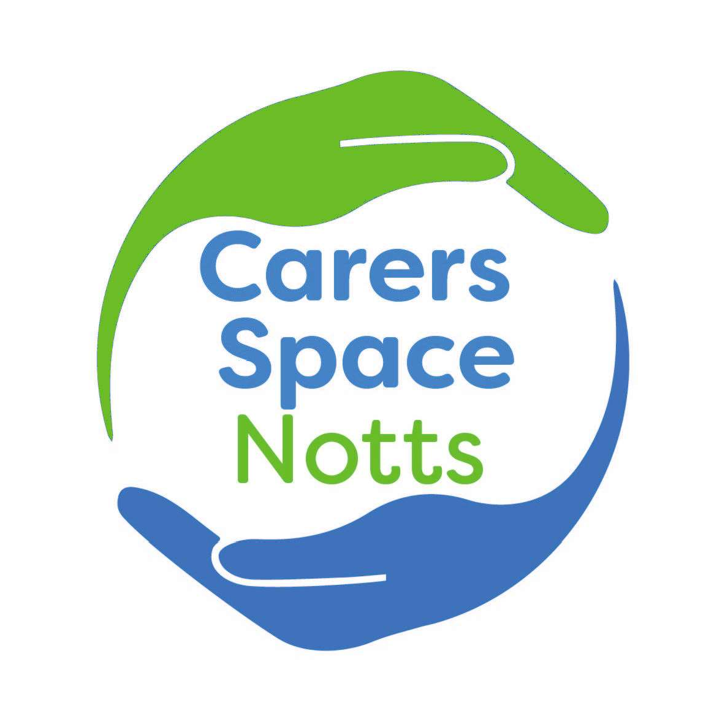

Carers Space Notts
Who are we?
- A group of unpaid carers who are passionate about carers having an equal voice with professionals when strategic decisions are made about services or policies in Nottinghamshire.

How did we start?
- At a listening event with Adult Social Care in July 2021 a carer raised concerns about the opportunities for carers to get involved and influence how services develop in Nottinghamshire.

- Adult Social Care asked Nottinghamshire Carers Association to work with them and carers to design a way for more carers to get involved in strategic projects.

Our aim
To ensure services and policies are developed and improved by carers having an equal voice when developed and reviewed in Nottinghamshire.

Why?
Although carers are at the heart of social care support in the UK, many feel unsupported and under strain.
Ensuring carers are an equal partner in designing services and policies that affect them in Nottinghamshire is an important part in trying to minimise the difficulties they experience and optimise services and support that works.

What do we want to do?
- Provide regular opportunities for carers in Nottinghamshire to connect, share information, ideas and have focussed discussions on strategic issues that are important to them.

- Establish links to groups that are important to carers, especially individuals that are not currently represented

- Share key themes from our conversations with organisations so that they can decide if we can look at them together in a co- production project.

- Recognising that when they cannot do this, information that affects their decision is fed back to us to improve our understanding.

- To invite professionals to join us, to listen and have conversations with us, when this is relevant to the group.

- To encourage everyone to share knowledge, so we all understand how different organisations work.

- To support carers to understand co-production and how they can influence change by working alongside professionals as equal partners, so we all consider better ways of delivering services.

- To share information and support carers to get involved with different projects taking place in Nottinghamshire.

- To share information with individuals, carers groups and organisations who want to know about what we are doing.

How will we start to achieve this?
- A monthly online meeting from January 2022, which any carer is welcome to attend.

- Every meeting will have a theme with time for a discussion and an open space at the end.

- Discussions and actions taken as a result of meetings will be shared with the group members and distribution lists.

- Work completed on projects outside of the group, with the participation/ input of group members will be fed back to the group at appropriate intervals.

- Carers Space Notts will invite key people from health, social care and other agencies when they need support to understand or discuss a particular topic.

- Staff will be asked to send anything they want to share at the meeting in advance so that carers have time to look at this before the meeting.

Training
Members will be offered training to help them understand co-production in Notts. Two sessions will take place during the first year.

How will carers and other people know what is happening?
- Posters/flyers will be developed to advertise the space as widely as possible:

o Tuvida (The Carers Hub), Nottinghamshire County Council, Parent Partnership, district and borough councils, GP’s, the social prescribing network and community groups.

- Information about Carers Space Notts will sit on Nottinghamshire Carers Association website with its own logo, social media presence and email address.

- After every meeting information will be shared to let other people know what happened.

- A news sheet will be sent out three times a year to summarise what has been learnt and achieved.
- We will ask people signed up to the Carers Space Notts contact list to help us review what is working and not working so we can make changes, using survey monkey or a similar tool.

